Annual Review guidance and additional documentation for education settings and professionals
The following guidance and new Annual Review forms have been produced to support educational settings when carrying out Live Annual Reviews.
There have been some minor amendments to the review documentation and so it is recommended that you download the updated templates which can be found on the Local Offer at www.telfordsend.org.uk
Contents:
Section 1 (page 1): Guidance document on the process required for Annual Reviews.
Section 2 (page 18): Guidance document to support specifically with the completion of the Annual Review form.

Section 1.
Telford and Wrekin Local Authority.
Guidance on the Annual Review process for an Education, Health and Care Plan.
Contents of Section 1 guidance document:
Introduction (page 2) / Reference to SEND Code of Practice Chapter 9
Quick guide (page 3)
Link to Annual review Documentation (page 3)
Annual Review Process Map (page 6)
When should an Annual Review be held? (page 7)
Who should arrange/attend the Annual Review? (page 8)
How much notice should be given? (page 9)
Prior to the Annual Review (page 9)
The Mental Capacity Act (page 10)
The Annual Review meeting – all pupils (page 12)
Additional requirements for an Annual Review for pupils from Year 9 onwards including Preparation for Adulthood (PfA) / Careers Advice (page 11)
Following the Annual Review (page 17)
When does paperwork need sending to the Local Authority (LA) (page 17)
What happens next? (page 17)

Introduction
This guidance is designed to support schools and educational settings in completing and conducting Annual Reviews of Education, Health and Care Plans (EHCPs). It is primarily intended for Special Educational Needs Co-ordinators (SENCos) and other professionals responsible for organising and leading Annual Reviews.
Annual Reviews play a vital role in ensuring that EHCPs remain accurate, relevant and effective in meeting a child or young person's needs. The review process should focus on the progress being made towards agreed outcomes, the continuing appropriateness of provision, and whether any amendments to the EHCP are required.
Schools and settings should also refer to Chapter 9 of the SEND Code of Practice (2015), Sections 9.166 to 9.185, which provides statutory guidance on Annual Reviews.
"EHC plans should be used to actively monitor children and young people's progress towards their outcomes and longer-term aspirations. They must be reviewed by the local authority as a minimum every 12 months. Reviews must focus on the child or young person's progress towards achieving the outcomes specified in the EHC plan. The review must also consider whether these outcomes and supporting targets remain appropriate."
(SEND Code of Practice, 2015, Section 9.166)
"As part of the review, the local authority and the school, further education college or section 41 approved institution attended by the child or young person must cooperate to ensure a review meeting takes place."
(SEND Code of Practice, 2015, Section 9.173)
Whilst the Local Authority has a statutory duty to ensure that Annual Reviews are completed, responsibility for arranging and conducting Annual Reviews in Telford & Wrekin has been delegated to schools and settings.
Telford & Wrekin uses a Live Annual Review approach. This is intended to reduce duplication, streamline the review process and ensure that proposed changes to the EHCP are captured directly within the most recent version of the plan. Schools and settings will receive the current EHCP in an editable Word format and are expected to review the document during the Annual Review process, recording any proposed amendments in line with the guidance set out in this document.
It is important to remember that an Annual Review does not automatically mean that an EHCP will be amended. The purpose of the review is to consider whether the EHCP remains appropriate. Amendments should only be recommended where there have been significant changes to the child or young person's needs, outcomes, provision, or circumstances.
This guidance should be used alongside the Annual Review forms and supporting documentation available through the Local Offer. Together, these documents will support schools and settings to complete high-quality Annual Reviews that provide the information required for the Local Authority to make informed decisions about the ongoing maintenance of EHCPs.
All Annual Review documentation can be found on our Local Offer –
https://www.telfordsend.org.uk/downloads/download/55/annual_review_documentation

Annual Review Quick Guide

✅ Arrange review meeting
✅ Invite attendees (6 weeks before if possible)
✅ Request reports
✅ Gather pupil and parent views
✅ Circulate paperwork (2 weeks before)
✅ Hold review meeting
✅ Complete Annual Review Form
✅ Amend EHCP using strike through and italics
✅ Submit complete paperwork within 2 weeks
✅ Await LA decision

When reviewing the EHCP:
✅ Review all sections of the EHCP
✅ Do not delete existing text
✅ Use strikethrough for information that is no longer accurate or relevant
✅ Add new information in italics
✅ Ensure all proposed changes are supported by evidence
Example
Original text:
X requires adult support during unstructured times.
Amended text:
X requires adult support during social situations and at times of increased anxiety.

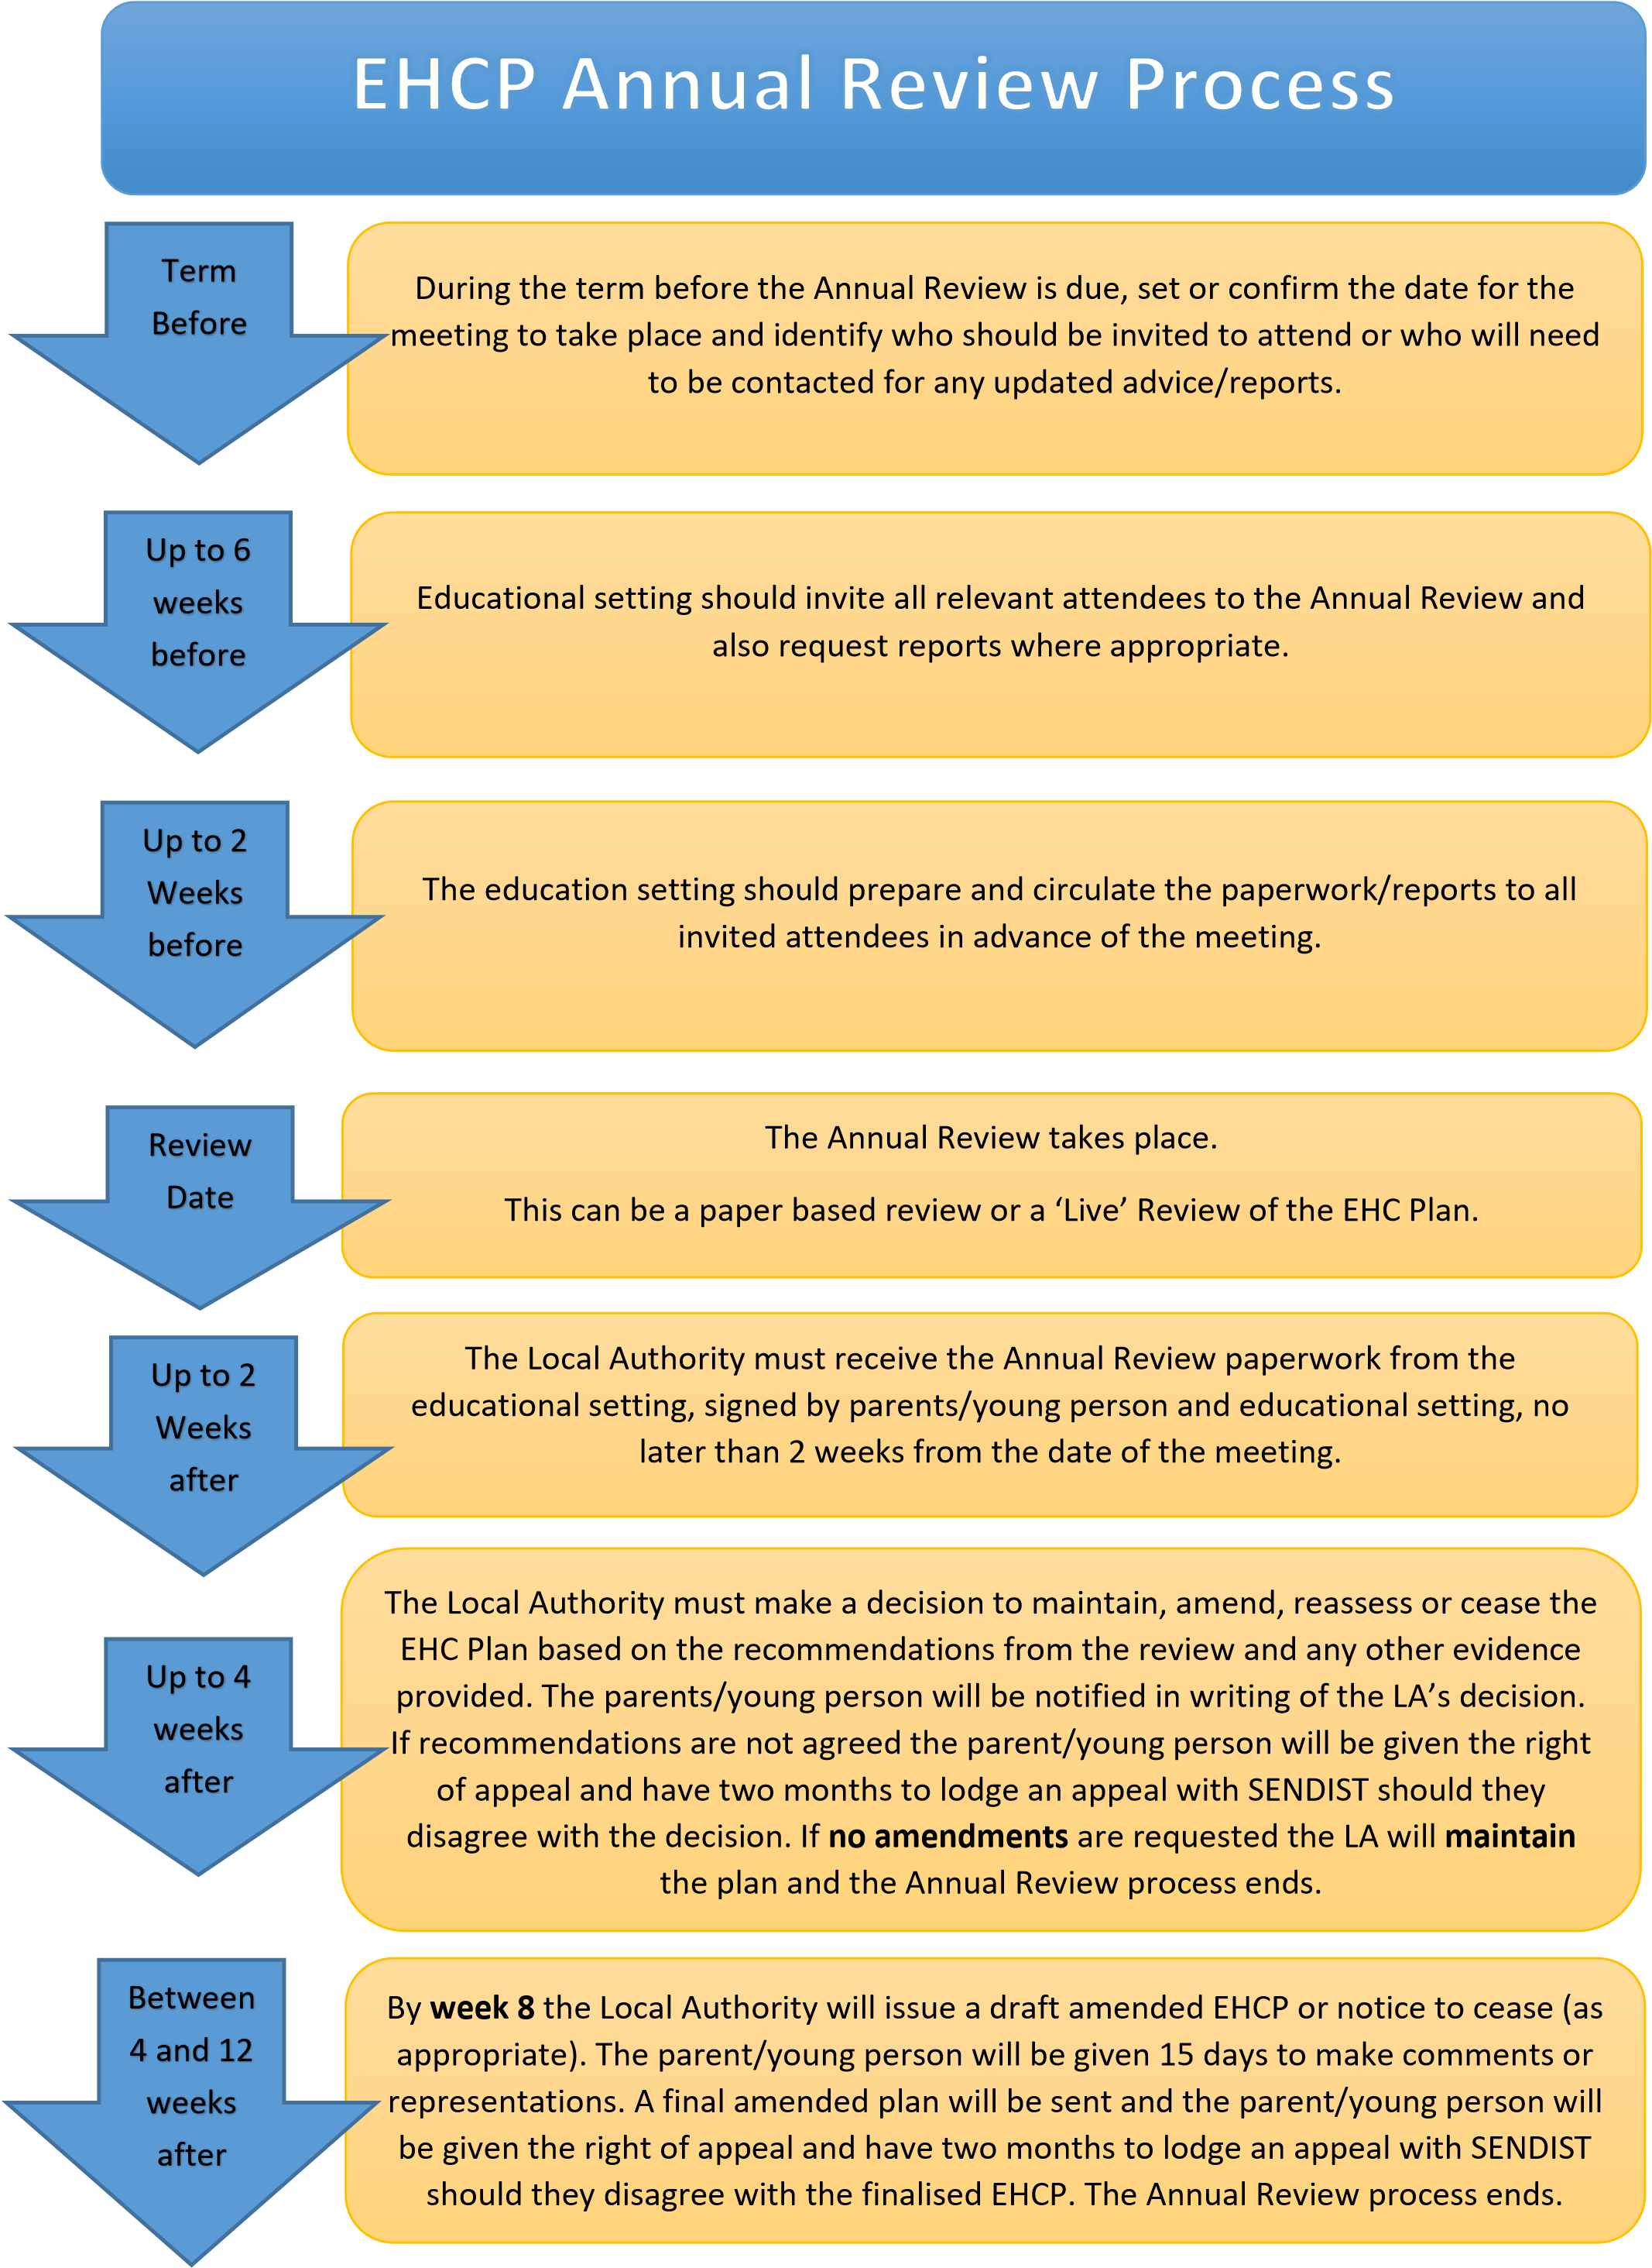

When Should an Annual Review Take Place?
The first Annual Review must take place within 12 months of the EHCP being issued. Thereafter, Annual Reviews must be held at least every 12 months from the date of the previous review.
A review may also be requested at any time by a parent/carer, young person, school/setting or professional where there has been a significant change in circumstances, needs or provision that may require the EHCP to be reconsidered.
Transition Reviews
Some Annual Reviews are subject to additional statutory requirements due to a child or young person's transition to a new phase of education.
Year 6 Reviews
For children transferring from primary to secondary education, the Annual Review should take place during the autumn term of Year 6, ideally before October half term, to allow sufficient time for transition planning and placement discussions.
Year 11 Reviews
For young people transferring to post-16 provision, the Annual Review should take place during the autumn term of Year 11. Discussions should focus on the young person's aspirations, post-16 options, Preparing for Adulthood outcomes and transition arrangements.
Schools and settings should invite representatives from prospective receiving settings wherever possible to support effective transition planning.
Children Aged 0-5
For children aged 0-5, Telford & Wrekin recommends that settings review progress and provision after six months to ensure the EHCP remains appropriate and effective. This interim review does not need to be submitted to the Local Authority but should be available to inform the next Annual Review.
Looked After Children
Where a child is looked after, the Annual Review should be aligned with the review of their Care Plan wherever possible, particularly the Personal Education Plan (PEP) review.
Young People in Custody
For young people detained in custody, the special educational provision arranged during detention should be monitored at least annually. A monitoring meeting should consider:
- The provision currently being delivered.
- The young person's progress.
- Whether their needs or circumstances have changed.
EHCPs cannot be amended or ceased whilst a young person is in custody. The EHCP should be formally reviewed following their release.
Note: A child becomes a young person at the end of the academic year in which they turn 16.

Who Should Arrange and Attend the Annual Review?
The school or educational setting is responsible for arranging and convening the Annual Review meeting.
The following people should be invited where appropriate:
Essential Attendees
- Parent(s)/carer(s) or the young person.
- Child/young person (where appropriate).
- Relevant school or setting staff.
Professionals Involved with the Child or Young Person
This may include:
- SEND Case Officer (where appropriate).
- Educational Psychologist.
- Health professionals.
- Social Care professionals.
- Sensory Inclusion Service.
- Short Breaks providers.
- Any other professional currently supporting the child or young person.
Transition Reviews
For transition reviews, schools and settings should invite representatives from prospective receiving settings wherever possible.
Examples include:
- Early Years to Primary School.
- Primary to Secondary School.
- Secondary School to Post-16 provision.
- Transfer between schools or settings.
Additional Support for Families
Parents/carers may wish to invite someone to support them during the meeting, for example:
- Information, Advice and Support Service (IASS).
- Advocate.
- Family member or friend.
Young people may also choose to be supported by an advocate or another trusted adult.
Good Practice: Invitations should be sent with sufficient notice to enable professionals, parents/carers and young people to attend and contribute effectively to the review process.

Preparing for the Annual Review
Notice of the Meeting
All attendees must be given a minimum of two weeks' notice of the Annual Review meeting.
However, Telford & Wrekin recommends providing at least six weeks' notice wherever possible. This helps maximise attendance and allows sufficient time for professionals, parents/carers and young people to submit reports and information in advance of the meeting.
Before the Annual Review Meeting
The person responsible for coordinating the review (usually the SENCo, Headteacher or another nominated member of staff) should:
✅ Invite all relevant professionals involved with the child or young person and request updated advice or reports.
✅ Invite the parent/carer or young person and provide them with the appropriate views form for completion before the meeting.
✅ Gather and record the views of the child or young person.
✅ Obtain and review relevant information, including:
- The current EHCP.
- School assessment data.
- Attendance information.
- Progress towards outcomes.
- Provision maps.
- Recent professional reports and assessments.
✅ Consult staff who work regularly with the child or young person to ensure their views and experiences are reflected within the review.
✅ Circulate all reports and information received to attendees at least two weeks before the review meeting.
Providing information in advance supports meaningful participation and enables contributors to prepare for informed discussions during the review

Mental Capacity Act and Annual Reviews
From the end of the academic year in which a young person turns 16, they are generally entitled to make decisions about their EHCP, including participating in Annual Reviews and expressing preferences regarding their education and support.
This right is subject to the Mental Capacity Act 2005 (MCA). Under the Act, a young person is presumed to have the capacity to make decisions unless an assessment demonstrates otherwise.
The SEND Code of Practice states:
"The right of young people to make a decision is subject to their capacity to do so as set out in the Mental Capacity Act 2005." (SEND Code of Practice, 2015, Section 8.19)
What Does This Mean for Annual Reviews?
For young people aged 16 and over, schools and settings should:
- Involve the young person as fully as possible in the review process.
- Ensure the young person's views, wishes and feelings are sought and recorded.
- Direct correspondence and decision-making discussions to the young person where they have capacity to make those decisions.
- Consider whether any support is required to help the young person understand information and participate in decision-making.
Where there are concerns about a young person's ability to make a specific decision, advice should be sought regarding a Mental Capacity Assessment.
The Five Principles of the Mental Capacity Act
When working with young people aged 16 and over, the following principles must be followed:
1. Presumption of Capacity
Every young person must be assumed to have capacity unless it is established otherwise.
2. Support to Make Decisions
All practicable support should be provided before deciding that a young person is unable to make a decision for themselves.
Examples may include:
- Using accessible language.
- Providing information in different formats.
- Allowing additional time for discussion.
- Involving advocates or trusted adults.
3. Right to Make Unwise Decisions
A young person should not be considered to lack capacity simply because they make a decision that others disagree with or consider unwise.
4. Best Interests
If a young person is assessed as lacking capacity to make a particular decision, any decision made on their behalf must be made in their best interests.
5. Least Restrictive Option
Any action taken or decision made on behalf of a young person who lacks capacity should interfere as little as possible with their rights and freedoms.
Further Information
Additional guidance regarding the Mental Capacity Act and its application to young people and their parents can be found in Annex 1 of the SEND Code of Practice: Mental Capacity.
Good Practice: Even where a young person lacks capacity to make a particular decision, they should still be involved in the Annual Review process as far as possible, and their views, wishes and feelings should continue to be sought and recorded.

Conducting the Annual Review Meeting
The Annual Review should be a person-centred discussion focused on the child or young person's progress, needs, aspirations and the effectiveness of the support outlined within their EHCP.
The chair should:
- Welcome attendees and facilitate introductions.
- Ensure the child/young person and parent/carer are fully involved in discussions.
- Confirm any invited professionals who are unable to attend.
- Ensure attendees have access to the current EHCP and any relevant reports.
During the review, consideration should be given to:
Progress and Outcomes
- Progress made towards the outcomes in the EHCP.
- Whether the outcomes remain relevant and appropriate.
- Any new outcomes that may be required.
Needs and Provision
- Whether the child or young person's needs have changed.
- Whether the provision specified within the EHCP remains appropriate and effective.
- Any evidence supporting proposed amendments.
Placement
- Whether the current setting remains suitable to meet the child or young person's needs.
- Any support, adjustments or resources required to maintain the placement.
Transport and Personal Budgets
- Current transport arrangements (where applicable).
- Any existing Personal Budget arrangements and whether further information has been requested.
Recommendations
The review should consider whether the EHCP should:
- Be maintained.
- Be amended.
- Be ceased.
- Be reassessed.
Any recommendations should be supported by evidence and clearly recorded within the Annual Review paperwork.

Additional Requirements for Year 9 and Above
From Year 9 onwards, Annual Reviews must include a focus on Preparing for Adulthood (PfA) and should reflect the young person's aspirations for adult life.
Discussions should include:
Employment, Education and Training
- Career aspirations and future goals.
- Careers Information, Advice and Guidance (IAG).
- Further education, training, employment and work experience opportunities.
Independent Living
- Developing independence skills.
- Future housing and support needs.
- Increasing participation in decision-making.
Community Inclusion
- Friendships, relationships and participation in community activities.
- Access to transport and opportunities within the local community.
Health
- Maintaining good physical and emotional health.
- Support from health services.
- Preparing for transition to adult health services where appropriate.
A summary of Careers Information, Advice and Guidance (IAG) should be included within Section A of the EHCP.

Transition Planning and Careers Guidance (Year 9 and Above)
Preparing for adulthood should be a key focus of Annual Reviews from Year 9 onwards and should be reflected within the EHCP outcomes and discussions.
Reviews should include consideration of:
Transition to Adult Services
- Planning for transition from children's to adult health and social care services.
- Ensuring effective communication and joint planning between services where appropriate.
Transition to Further Education (FE)
- Discussing post-16 education, training and employment aspirations.
- Helping young people understand the options available to them and the support that may be available.
- Exploring local Further Education providers and pathways.
- Supporting young people to access open days, taster sessions and transition activities where available.
- Inviting representatives from prospective post-16 settings to attend Annual Reviews where appropriate, particularly from Year 10 onwards.
Preparing to Leave Further Education
Where a young person is approaching the end of their education, discussions should focus on:
- Employment and training opportunities.
- Higher education options.
- Adult health and social care services.
- Community support and participation.
- Developing a clear transition or exit plan.
Preparing for Adulthood Outcomes
Preparing for Adulthood should be embedded throughout the EHCP and Annual Review process, with consideration given to:
- Employment, education and training.
- Independent living.
- Community inclusion.
- Health and wellbeing.

Careers Information, Advice and Guidance (IAG)
Schools and colleges have a responsibility to ensure that children and young people receive independent careers guidance and are supported to raise their aspirations and make informed decisions about their future.
This may include:
- Careers guidance interviews.
- Work experience opportunities.
- Employer engagement activities.
- Mentoring programmes.
- Taster sessions and visits.
- Opportunities to explore further education, training and employment pathways.
A summary of Careers Information, Advice and Guidance (IAG) should be recorded within Section A of the EHCP from Year 9 onwards.
FutureFocus is Telford & Wrekin Council's specialist careers service, providing impartial information, advice and guidance to young people aged 13-19, or up to 25 for those with an EHCP.
Further information, including the FutureFocus SEND Pathways to Adulthood Booklet, can be found on the Local Offer:
https://www.telfordsend.org.uk/homepage/8/transition
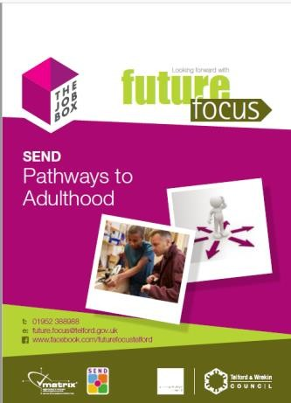

Further detailed information on PfA can be found on the Local Offer here

Following the Annual Review
Following the review meeting, the chairperson (usually the SENCo or Headteacher) should:
- Complete the Annual Review Form.
- Ensure any proposed amendments have been made directly within the EHCP using strikethrough for information to be removed and italics for new information.
- Obtain the required agreement signature(s) where appropriate.
- Submit all Annual Review paperwork and supporting documents to the Local Authority.
Submitting the Review
Please send the completed paperwork to:
SEND Team
Email: sendandinclusion@telford.gov.uk
Where required, documents should be sent via encrypted email in accordance with your setting's information governance procedures.
Word versions of documents are preferred to support the amendment process.
If you are unable to use encrypted email, paperwork may be posted to:
The SEND Team
Telford & Wrekin Council
6B Darby House
Lawn Central
Telford
TF3 4JA

Submission Timescales
The completed Annual Review paperwork, amended EHCP (where applicable) and all supporting documents must be submitted to the Local Authority within two weeks of the Annual Review meeting.
Meeting this timescale is essential to enable the Local Authority to meet its own statutory duties and decision-making timescales.

What Happens Next?
Once the Local Authority receives the Annual Review paperwork, it will consider:
- The Annual Review recommendations.
- Any proposed amendments to the EHCP.
- Supporting evidence and professional reports.
- The views of the child or young person and their parent/carer.
Following this review, the Local Authority will notify the parent/carer, young person and school of its decision to:
- Maintain the EHCP.
- Amend the EHCP.
- Cease the EHCP.
The Local Authority aims to issue its decision within four weeks of the Annual Review meeting.
Where amendments are proposed, a draft amended EHCP will be issued for consultation before a final EHCP is produced.
Please note: The Local Authority can only meet statutory timescales where Annual Review paperwork is submitted within the required two-week deadline.

Support and Advice
If you require advice regarding the Annual Review process, please contact:
- Your allocated SEND Case Officer; or
- The SEND Team on 01952 381045; or
- sendandinclusion@telford.gov.uk.

Section 2.
Completing the Annual Review Form

Pupil Information
Check and update

Attendance Data
Provide attendance for:
- Current academic year
- Previous academic year

Meeting Attendance Record
Complete the table showing:
- Individuals invited
- Individuals who attended
- Whether reports were requested and received
This should include professionals, parents/carers and the child or young person where appropriate.

Progress, Outcomes and Current Needs

Progress since last review - Consider progress towards the outcomes currently recorded in Section E.
Attach any relevant short term targets where appropriate.

Current Attainment Data
Complete the box provided of current attainment or attach a recent school report.

Are the outcomes as identified in the EHCP remaining the same?
Consider whether the long-term outcomes in Section E of the EHCP remain appropriate based on the child or young person's current needs, progress and aspirations.
Select "Yes" if:
- The outcomes remain relevant and appropriate.
- Progress is being made towards the outcomes.
- There have been no significant changes to needs that would require different outcomes.
Select "No" if:
- An outcome has been achieved and needs replacing.
- An outcome is no longer relevant.
- There have been significant changes in the child or young person's needs, circumstances or aspirations.
- New outcomes are required to better reflect current needs or future aspirations.
If selecting "No", please identify:
- Which outcome(s) need to be changed.
- Why the outcome(s) are no longer appropriate.
- Any proposed new or amended outcome(s).
Year 9 and above: Outcomes should reflect the Preparing for Adulthood areas of Employment/Education, Independent Living, Community Inclusion and Health where appropriate.
Please ensure any proposed changes are supported by evidence provided as part of the annual review.

Suitability of Placement
Important:
Settings should not advise parents/carers that a child needs to move placement. Any decision regarding placement is the responsibility of the Local Authority.

Consider whether the setting remains able to meet the child's needs.
Select One:
☐ Yes - needs can be met within current provision
☐ Yes - with adjustments
☐ No - needs can no longer be met
If concerns are identified, provide evidence of:
- Strategies and interventions already implemented
- Advice obtained from support services
- Adjustments already made
- Additional support required

Parent/carer views
☐ Parent/carer has expressed a preference for the current setting to remain
Select if the parent/carer has stated they would like the child or young person to continue attending their current educational setting.

☐ Parent/carer has expressed a preference for a different setting
Select if the parent/carer has indicated that they would like the child or young person to attend a different school, college or educational provision. Please record relevant details within the meeting discussion section.

☐ General discussion about support needs only
Select if placement was not discussed in detail and conversations focused on the child or young person's needs, provision, support arrangements or progress.

Important: Schools and settings should accurately record parental views but should not advise parents/carers that a child or young person requires a change of placement. Decisions regarding placement are the responsibility of the Local Authority.

Action Points
Record:
- Key discussion points
- Agreed actions
- Person responsible
- Timescales
This should provide a clear record of outcomes from the review meeting.

Banding Requests
If requesting an increase in funding, provide:
- Details of current provision
- Evidence supporting the request
- Costed provision map where applicable

Personal Budget
Ask whether the parent/carer or young person would like information about a Personal Budget.
http://www.telfordsend.org.uk/localofferservices/homepage/10/personal_budgets

If a Personal Budget is already in place, ensure the EHCP reflects current arrangements.

Transport
Complete this section only if transport is currently provided.
Review:
- Current travel arrangements
- Continued eligibility
- Changes required
- Independent travel training opportunities
Record any agreed actions.

Recommendations
Annual reviews are intended to consider whether an EHCP remains appropriate. A review does not automatically result in amendments. Amendments should only be recommended where there have been significant changes to need, provision or outcomes.
Select one recommendation only:
☐ Maintain EHCP
☐ Amend EHCP
☐ Cease EHCP
☐ Reassessment of Needs
Reassessment of Needs
A reassessment should only be recommended where there is evidence that the child or young person’s needs have significantly changed and current information is no longer sufficient to determine appropriate provision.
Please provide supporting evidence where amendments, reassessment or cessation are being recommended.

Signatures
Where all attendees are in agreement with the content and recommendations arising from the Annual Review, a signature should be obtained in the Agreement of Content of Review section.
The signature confirms that the review has been discussed and that those present agree with the information recorded and recommendations made.
If there are any areas of disagreement, these should be clearly recorded within the Annual Review paperwork.
Privacy Notice under the Data Protection Act
Telford & Wrekin Council are collecting Personal Identifiable Information to enable the best possible advice and support to be provided and to meet the statutory requirements under the Children and Families Act 2014. We need to collect this information in order to consider your request for an Education Health Care Needs Assessment. This information is being processed under DPA – Schedule 2 (2a) (GDPR 2018 -Article 6 (1) (c), Article 6(1)(e) and Article 9(2)(g).
Telford & Wrekin Council will not share any Personal Identifiable Information collected with external organisations unless required to do so by law. However, this information will be shared within Telford & Wrekin Council and partners agencies (Department of Education, NHS, Schools/settings, and Early Years providers) solely for the purpose of providing support to you and your family. For further details on the council’s privacy arrangements please view the privacy page on the council’s website page http://www.telford.gov.uk/terms

Submitting the Annual Review
Within two weeks of the review meeting, submit:
✅ Completed Annual Review Form
✅ Annotated EHCP (Word version)
✅ Parent/carer views
✅ Pupil views
✅ Professional reports
✅ Provision map (where applicable)
✅ Preparing for Adulthood Form (Year 9+)
Please submit all documents together as a single, complete review pack.
Incomplete submissions may be returned and could delay decision-making.

What Happens Next?
The Local Authority will review:
- The Annual Review documentation
- The amended EHCP
- Any supporting evidence
Where amendments are proposed, a draft amended EHCP will be issued to the parent/carer or young person for consultation.
Once agreed, a final EHCP will be issued. Schools/settings will receive:
- A signed PDF copy
- An editable Word version for future reviews

Confidentiality and GDPR
Please ensure all documentation is handled in accordance with:
- Data Protection legislation
- GDPR requirements
- Your setting's confidentiality policies
- Local Authority information-sharing requirements
For further information, visit: www.telford.gov.uk/terms

