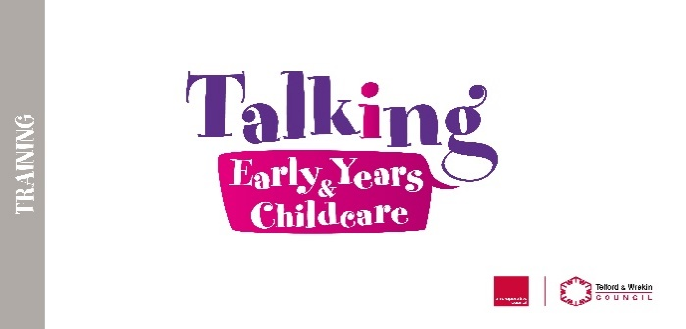

**Early Years SENCO Network**

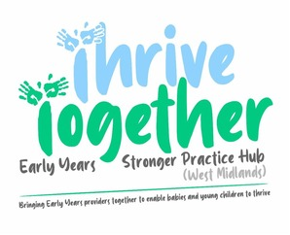

**Content:**

* **Key Speaker – Andrina Flinders ‘Beyond Attention Bucket** (Bringing strategies and skills into daily inclusive classroom practice )
* **SEND updates/changes (Representative from LA SEND team)**
* Introduction to EY SEND Support Package for Schools (EYFS/Reception)
* **Preparing for transitions**
* **Training opportunities**

**Target Audience:**

This session is aimed at Childminders/ Early Years SENCOs working with children in private, voluntary and independent settings

**Course Details**

**Dates:** Tuesday 20th May 2025  **Time:** 6:30 – 8:00 pm  
**Course Cost:** FREE

**Venue:**  Telford Mercure Hotel

**Please note: *Booking is essential to ensure sufficient resources/seating***

To book a place on this course please contact [talkingchildcare@telford.gov.uk](mailto:talkingchildcare@telford.gov.uk)

01952 383011